Scottsboro Boys
Abbreviated notes from: http://en.wikipedia.org/wiki/Scottsboro_Boys (accessed 9/9/09)
The Scottsboro Boys were nine black defendants in a 1931 rape case initiated in Scottsboro, Alabama. The case was heard by the United States Supreme Court twice and the decisions established the principles that criminal defendants are entitled to effective assistance of counsel and that people may not be de facto excluded from juries because of their race.
Nine young black defendants were accused of raping two fellow homeless white women on a freight train, and eight were quickly convicted in a mob atmosphere. The juries were entirely white, and the defense attorneys had little experience in criminal law and no time to prepare their cases. As each of the nine cases successively went to the jury, the next trial was immediately begun. All but one of the defendants was found guilty, and these eight were sentenced to death on rape charges. These eight, however, later had their death sentences lifted by the Supreme Court, serving instead between six and nineteen years in prison.
The nine black youths, Olen Montgomery (age 17), Clarence Norris (age 19), Haywood Patterson (age 18), Ozie Powell (age 16), Willie Roberson (age 17), Charlie Weems (age 19), Eugene Williams (age 13), and brothers Andy (age 19) and Roy Wright (age 12) were accused of the rapes of Ruby Bates and Victoria Price on March 25, 1931, on the Southern Railroad line from Chattanooga to Memphis. Several people were "hoboing" on the freight train including the nine black youths, two white women, and several white youths. Four of the blacks, Patterson, Williams, and the Wright brothers had hoped to find work hauling logs on the Missouri River. The other black youths on the train were from Georgia and were unacquainted with the other four. The white hobos on the train were also in search of work and included several boys or men and Victoria Price and Ruby Bates. The women were Huntsville, Alabama residents who had gone to Chattanooga, Tennessee to find work in cotton mills. Failing to obtain those jobs, they hopped this freight train back to Huntsville, completely without money.
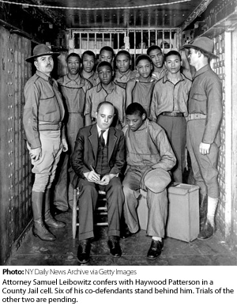
A fight began between the white youths and the black youths, allegedly when a white youth stepped on Patterson's hand as he hung on to the side of a tank car. The off-and-on fight involved name-calling, stone throwing and fisticuffs. Most of the white youths were forced off the slow moving train near Stevenson, Alabama. Several of them told the Stevenson stationmaster about the fight and said they wanted to press charges. The stationmaster called Jackson County Sheriff Matt L. Wann to report the incident. The Sheriff called Deputy Charlie Latham, who lived near the next scheduled stop for the train, Paint Rock, Alabama and told him to deputize as many citizens as he needed to "capture every negro on the train. I am giving you authority to deputize every man you can find." A posse of some fifty white men armed with shotguns, rifles and pistols prepared for their arrival. Even before the slow moving train stopped about 2 p.m., the posse had searched all forty-eight cars. Within ten minutes they had arrested all nine of the "raggedly dressed" black youths at gun point. From the time of their arrest until the first trial twelve days later, none of the boys were permitted to call or speak to anyone, not even each other. The initial arrest was for the assault and attempted murder of the white youths ejected from the train at Stevenson.
The posse was surprised to find Ruby Bates and Victoria Price on the train, dressed in men's overalls covering dresses. When discovered, they scrambled out of the open gondola car used to haul gravel where they had been riding. They ran in the direction of the engine, where they ran into other members of the posse coming the other way. They turned and started to run back in the other direction where other members of the posse stopped them. Twenty minutes after the train left Paint Rock, its station agent W. H. Hill asked the women whether any of the "negroes" had bothered them. At that point, Ruby Bates told Hill that they had been raped by them.
In the Jim Crow South, a black male was said to risk lynching by just looking at a white woman. Word quickly spread and a lynch mob gathered in front of the jail in Scottsboro and prepared to storm the jail. The crowd of farmers with many of their wives and children looking on grew into the hundreds. The newly elected Jackson County Sheriff, Matt L. Wann barricaded the door to the jail. At 8:30 that evening, he decided to move the accused youths to a jail in another community, but could not, because the wires to the headlights on the squad cars had been cut. Mayor James David Snodgrass begged the crowd to leave. However, they refused and demanded that the youths be surrendered to them for immediate lynching. At the request of Sheriff Wann, Alabama Governor Benjamin M. Miller, called in the National Guard to protect the jail. Authorities pleaded against mob violence by promising speedy trials and asking "the Judge to send them to the chair". The editor of the local Scottsboro Progressive Age was very self congratulatory that Scottsboro had not lynched these defendants outright. The editor wrote, "If ever there was an excuse for taking the law into their own hands, surely this was one. Nevertheless, the People of Jackson County have saved the good name of the county and state by remaining cool and allowing the law to take its course." [without benefit of any research or preparation time by lawyers who were not experience or familiar with Alabama trial law, individual trials moved forward quickly with large crowds in the streets outside the courthouse.]
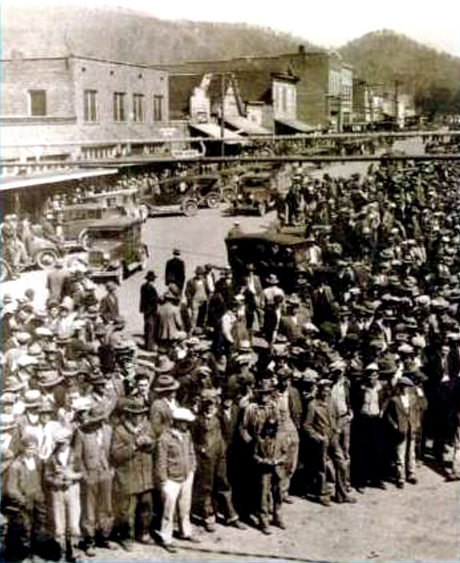
When the guilty verdicts were announced, the courtroom erupted in cheers and some of the celebrating crowd poured out into the street in front of the courthouse. Judge Hawkins' heavy gavel pounding did not restore order in the courtroom. He ended up ordering the national guardsmen to restore order, who ended up throwing eight of the shouting spectators out of the courthouse. When word of the guilty verdicts reached the crowd outside, another roar of celebration went up. The band, supplied for the occasion by the Ford Motor Company for a show of its cars outside, struck up Hail, Hail the Gang's All Here and There'll be a Hot Time in the Old Town Tonight.
The eight convicted defendants were assembled together on April 9, 1931 to be sentenced by the Court to death by electrocution, the first time Judge Hawkins had pronounced the death sentence in his five years on the bench. The Associated Press reported that the defendants were "calm" and "stoic", as Judge Hawkins handed down the death sentences one after another.
Judge Hawkins fixed their executions for July 10, 1931, which was the earliest date Alabama law allowed. The defendants were immediately sent to death row in Kilby Prison in Montgomery, Alabama. Their cells were next to the execution chamber. While appeals were filed for them, the Alabama Supreme Court issued indefinite stays of executions for them only seventy-two hours before they were scheduled to die. During their wait on death row, another prisoner, Will Stokes, was executed on July 10, 1931, which they could hear. They later recalled that Stokes had "died hard".
Many in the North were outraged by the decision of the Alabama Supreme Court and many in the South were outraged by the outrage, since, to their way of looking at it, the whole fuss was caused by "outside agitators." They had, after all, given these defendants a trial, rather than just lynching them the first night. Many in the South asked, "What more did those Communist trouble makers want?" The ILD retained prominent constitutional attorney Walter Pollak to appeal the case to the United States Supreme Court which appeal, the Supreme Court agreed to hear. [Twice the US Supreme Court heard and overturned convictions from the Alabama Courts.] [After multiple re-trails which included two hearings before the US Supreme Court, all the Scottsboro Boys were ultimately released (or escaped) from prison. Individual outcomes included]
1. Haywood Patterson: On January 23, 1936, in this retrial, Haywood Patterson was again convicted of rape but was sentenced to 75 years in prison rather than the death penalty—the first time a black man had been sentenced to anything other than death in the rape of a white woman in Alabama. There was a Methodist minister on the jury who persuaded the others to agree to this sentence as a "compromise." Victoria Price expressed her extreme disappointment that Patterson escaped the death sentence this time, pronouncing bitterly that it was extremely unfair that he would get off with only 75 years. Haywood Patterson escaped in 1948 and fled to Detroit, Michigan.
2. On July 15,1937, Clarence Norris was again convicted of rape and sexual assault and sentenced to death. Governor of Alabama Bibb Graves later reduced Clarence Norris' death sentence to life in prison. He was paroled in 1946. In 1979 his autobiography The Last of the Scottsboro Boys was published in which he described his ordeal. The last living Scottsboro Boy wanted to clear his name. Norris died January 23, 1989 when at 76.
3. On July 22, 1937, Andrew Wright was again convicted of rape and sentenced to 99 years. He was paroled, but returned to prison after violating his parole. He was finally released for good in 1950.
4. On July 24, 1937, Charlie Weems was convicted of rape and sentenced to 105 years in prison. He was paroled in 1943, having served 12 years in some of the worst prisons in the nation.
5. Ozie Powell pleaded guilty to assaulting a Deputy Sheriff named Edgar Blaylock with intent to murder him during an escape attempt and was sentenced to 20 years. Judge Callahan did not give him any credit for the six years he had already served on the rape charge. However, the state did drop the rape charges against him as part of this plea bargain. The incident happened on January 24, 1936. Powell was finally released for good in 1946.
6. On July 24, 1937, Roy Wright had all charges against him dropped; the state said that they felt that given his age, and time served, he should now be released. He joined the United States Army. When he got out of the Army, he married and joined the Merchant Marine. After Wright came back from a lengthy time at sea in 1959, he came to believe that his wife had been unfaithful to him during his absence. As a result, he shot his wife to death and then took his own life.
7. On July 24, 1937, Eugene Williams had all charges against him dropped, for the same reasons given for Wright.
8. On July 24, 1937, Olen Montgomery had all charges against him dropped, as the state announced that after consideration, it now believed him to be not guilty.
9. On July 24, 1937, Willie Roberson had all charges against him dropped, for the same reasons given for Montgomery. While it has sometimes been suggested that the case inspired Harper Lee's Pulitzer Prize winning To Kill a Mockingbird, Lee denied this, claiming it was a far less sensational case that moved her to write the novel.
Abbreviated notes from: http://en.wikipedia.org/wiki/Scottsboro_Boys (accessed 9/9/09)

Name: __________________________________________ Date: ____________________ Period: _____
Trials of the Scottsboro Boys
1. What were the Scottsboro Boys accused of and based on the notes provided what was the evidence against them?

2. How and why were the Scottsboro Boys and Ms. Bates and Price traveling?

3. Would you be willing to travel in a similar way? Why/why not?

4. Based only on the notes you received, can you make any judgment as to whether or not the Scottsboro boys’ first trials were fair? (please support your position from information from the notes)

