In your small group, review the questions on this worksheet and then read Life During the Depression. Discuss the questions and provide your responses with supporting evidence from the text ON A SEPARATE PIECE OF PAPER.
1. How was the health and nutrition of people impacted by the depression?
2. Describe how women’s and child employment changed during the depression.
3. What type of impact did the Great Depression have on minority populations?
4. What personal values would help a person successfully get through a situation like the Great Depression? Identify the values and describe how they would help a person.

Life During the Depression
By. John C. Cunningham, Encyclopedia Britannica
The Great Depression had a substantial and varied impact on the lives of Americans. Physically and psychologically, it was devastating to many people, who not only lacked adequate food, shelter, and clothing but felt they were to blame for their desperate state.
Although few people died from starvation, many did not have enough to eat. Some people searched garbage dumps for food or ate weeds. Malnutrition took a toll: A study conducted in eight American cities found that families that had a member working full time experienced 66 percent less illness than those in which everyone was unemployed.
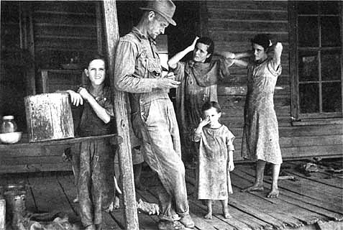
Because society expected a man to provide for his family, the psychological trauma of the Great Depression was often more severe for men than women. Many men argued that women, especially married women, should not be hired while men were unemployed. Yet the percentage of women in the workforce actually increased slightly during the depression, as women took jobs to replace their husbands’ lost pay checks or to supplement spouses’ reduced wages. Women had been excluded from most of the manufacturing jobs that were hardest hit by the depression, which meant they were less likely than men to be thrown out of work. Some fields that had been defined as women’s work, such as clerical, teaching, and social-service jobs, actually grew during the New Deal.
The effects of the depression on children were often radically different from the impact on their parents. During the depression many children took on greater responsibilities at an earlier age than later generations would. Some teenagers found jobs when their parents could not, reversing the normal roles of provider and dependent. Sometimes children had to comfort their despairing parents. A 12-year-old boy in Chicago, for example, wrote to President and Mrs. Roosevelt in 1936 to seek help for his father, who was always “crying because he can’t find work [and] I feel sorry for him.” The depression that weakened the self-reliance of many adult men strengthened that quality in many children.
The depression’s impact was less dramatic, but ultimately more damaging, for minorities in America than for whites. Since they were “born in depression,” many blacks scarcely noticed a change at the beginning of the 1930s. Over time, however, blacks suffered to an even greater extent than whites, since they were usually the last hired and first fired. By 1932 about 50 percent of the nation’s black workers were unemployed. Blacks were frequently forced out of jobs in order to give them to unemployed whites. Yet the depression decade was one of important positive change for blacks. First lady Eleanor Roosevelt and several leading New Deal figures were active champions of black rights, and most New Deal programs prohibited racial discrimination. These rules were often ignored in the South, but the fact that they were included at all was a major step forward. Blacks were sufficiently impressed with the New Deal to cause a large majority of black voters to switch their allegiance from the Republican to the Democratic Party during the depression years. See also African American History.
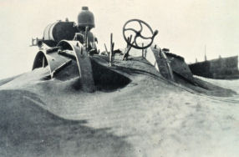
Other minority populations had experiences similar to those of blacks during the depression. Native Americans were even less likely than blacks to notice a downturn when the depression began; they already fared poorly by virtually every social or economic indicator. But Native Americans, like blacks, were brought into New Deal relief programs that in theory did not discriminate, and an attempt was made, through the Indian Reorganization Act, to enable tribes to reestablish their identities and cultural practices. In industrial cities such as Detroit, Gary, and Los Angeles and in agricultural regions such as California’s San Joaquin Valley, Mexican Americans were seen as holding jobs that should go to whites. Repatriation (meaning deportation) programs were instituted to persuade Chicanos to return to Mexico, often through intimidation.
Groups of white Americans also faced discrimination during this era. Poor farmers evicted from their land or fleeing the Dust Bowl were often despised and abused when they arrived in California and other western states. They were commonly labeled “Okies,” whether they came from Oklahoma or other states.
VIII. END OF THE DEPRESSION
Although economic conditions improved by the late 1930s, unemployment in 1939 was still about 15 percent. However, with the outbreak of World War II in Europe in September 1939, the U.S. government began expanding the national defense system, spending large amounts of money to produce ships, aircraft, weapons, and other war material. This stimulated industrial growth, and unemployment declined rapidly. After the United States entered the war in December 1941, all sectors of the economy were mobilized to support the war effort. Industry greatly expanded, and unemployment was replaced by a shortage of workers.

