Name: ______________________________________________ Date: ____________________ Period: _____
The Great Gatsby Character Map
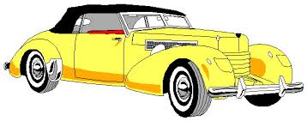
Myrtle Wilson
Tom Buchanan
Jay Gatsby
George Wilson
Nick Carroway
Jordan Baker
Daisy Buchanan

