Name: _____________________________________________________________ Date: __________________________ Period: ______
BRAINSTORMNG FOR COMPARE & CONTRAST ESSAY
- List attributes or qualities of theme of literary being a form of power in the circle, placing any shared qualities in the overlapping section. Be specific and use details. (Example: details of living in SB might include high cost of living, beach community, good schools, etc. Less effective qualities: not nice place, cool hangouts.)
- Circle the most important qualities in each list and match at least three opposites from one circle to another.
Malala Yousafzai
Frederick Douglass

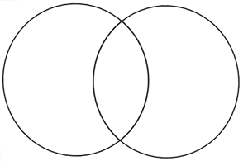
After completing steps 1-3, list similarities or differences (Have at least 1 difference):
1.

2.

3.

- Review the lists and identify three similarities and differences. List the categories in the box above.
- Then choose one option (point by point or block method) to structure your essay. (See examples in essay directions handout.)
- Use the chart on the next page to organize your paragraphs as indicated. Add more ideas and details for each category as you think of them.

